

COMSATS UNIVERSITY ISLAMABAD
ATTOCK CAMPUS

Computer Science Department
BSSE-6

PROJECT TITLE : AIRLINES MANAGEMENT SYSTEM

SUBMITTED TO:
DR. SADAF YASMEEN
SUBMITTED BY:
ZAINAB KHAN (FA22-BSE-032)
MANAHIL TARIQ (FA22-BSE-050)
ANUM HAMEED (FA22-BSE-048)

DATE OF SUBMISSION:
3RD JUNE, 2025

1. MAIN FEATURES:
- User Registration with email validation.
- Secure Login with username and password.
- View Available Flights by departure location.
- Flight Booking by entering flight number.
- Booking Confirmation shown via pop-up messages.
- Booking History Viewing (can be enhanced).
- Logout functionality returning to login screen.
- GUI built using Java Swing with grey background and white text for accessibility.
How app meets core requirements:
- Registration prevents duplicate usernames.
- Validates emails during signup.
- Flight booking only allowed for logged-in users.
- Flight availability managed via isBooked flag.
- Real-time feedback via dialog boxes for errors and confirmations.
- Data stored in-memory using HashMap for users and ArrayList for flights.
- Menu-driven console flow supported through Swing components.
2. CODE AND PROJECT REPOSITORY
Code Structure:
- Flight.java — Flight entity class storing flight details and booking status.
- User.java — User entity class managing credentials and authentication.
- Main.java — Main application class with GUI, event handlers, and business logic.
- Data storage implemented with HashMap<String, User> for users and ArrayList<Flight> for flights.
- GUI components: JFrame, JTextField, JPasswordField, JTextArea, JButton, etc.

3. AI TOOL USAGE SUMMARY
AI Tools Used:
- ChatGPT for code generation, debugging, and documentation support.
Prompts Used:
- “Generate Java Swing login and registration screens with email validation and password fields.”
- “Implement flight booking logic in Java with booking confirmation dialogs.”
- “How to set grey background and white text on Java Swing buttons?”
- “Add error handling for duplicate usernames in registration.”
Outputs Incorporated:
- Complete user registration and login code with validation logic.
- GUI styling suggestions applied.
- Flight management code, including booking and confirmation messages.
- Error handling and input validation.
Reflection on Usefulness and Limitations:
- AI significantly reduced development time by generating base code and validation logic.
- Provided clear examples for common Swing UI patterns.
- Required customization for UI theme and integration with overall system logic.
- Occasionally AI suggestions needed debugging and refinement.
4. PROJECT REFLECTION REPORT
What Changed From Original Design:
- Added password field for secure login, improving user authentication.
- Implemented email validation using regex during registration.
- Added confirmation dialogs for booking and error notifications to improve UX.
- Minor UI improvements for better readability: consistent color scheme (grey background, white text).
- Enhanced booking process to prevent booking already booked flights.
What AI Tools Helped or Confused You:
- ChatGPT was very helpful for writing boilerplate UI code and business logic.
- It clarified how to structure Swing event handlers.
- Some AI code was generic and needed adapting to project specifics.
- Initially, AI suggestions around UI styling were limited; manual tweaks were necessary.
What Would You Do Differently Next Time:
- Plan UI layout and design more thoroughly before coding to minimize redesign.
- Use AI tools as assistants but always review and adapt generated code.
- Integrate version control (Git) early for better team collaboration and code tracking.
- Explore automated testing and build scripts to complement AI-assisted coding.
- Possibly extend the system to use a persistent database instead of in-memory structures for real-world deployment

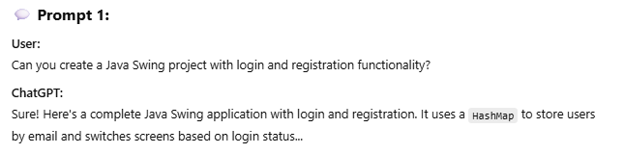
CHAT GPT PROMPTS & OUTPUT :
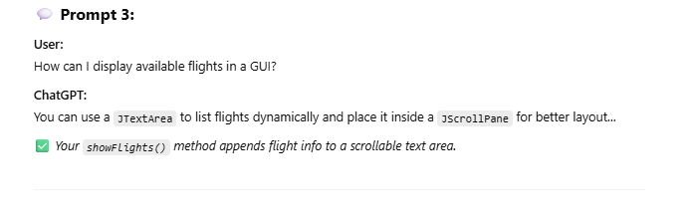
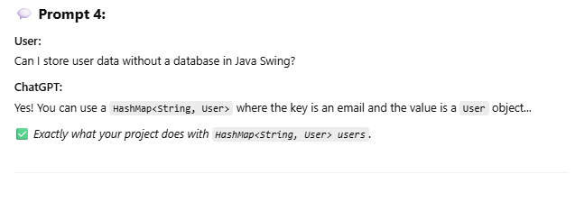
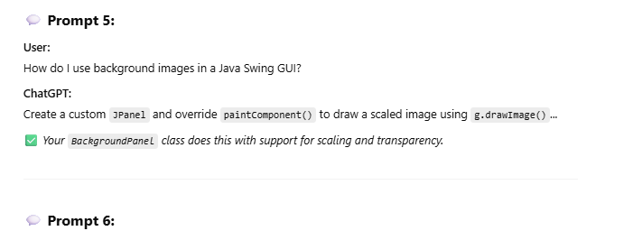
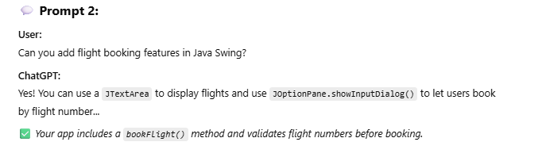

CODE:
import javax.swing.*;
import java.awt.*;
import java.util.ArrayList;
import java.util.HashMap;

class Flight {
int flightNumber;
String from, to, departureTime, arrivalTime, day;

public Flight(int flightNumber, String from, String to, String departureTime, String arrivalTime, String day) {
this.flightNumber = flightNumber;
this.from = from;
this.to = to;
this.departureTime = departureTime;
this.arrivalTime = arrivalTime;
this.day = day;
}
}

class User {
String name, email;

public User(String name, String email) {
this.name = name;
this.email = email;
}
}

// Custom JPanel that paints a scaled background image
class BackgroundPanel extends JPanel {
private Image backgroundImage;

public BackgroundPanel(String imagePath) {
backgroundImage = new ImageIcon(imagePath).getImage();
setOpaque(false); // make panel transparent for layering
}

@Override
protected void paintComponent(Graphics g) {
super.paintComponent(g);
// Draw scaled image to fill entire panel
g.drawImage(backgroundImage, 0, 0, getWidth(), getHeight(), this);
}
}

public class AirlineApp {
private JFrame frame;
private JPanel loginPanel, mainPanel;
private JTextField nameField, emailField;
private JButton loginButton, registerButton, viewFlightsButton, bookFlightButton, logoutButton;
private JTextArea flightsArea;

private HashMap<String, User> users = new HashMap<>();
private ArrayList<Flight> flights = new ArrayList<>();
private User loggedInUser = null;

public AirlineApp() {
frame = new JFrame("Airline Management System");
frame.setDefaultCloseOperation(JFrame.EXIT_ON_CLOSE);
frame.setSize(700, 450);
frame.setLayout(new CardLayout());

createLoginPanel();
createMainPanel();
addFlights();

frame.add(loginPanel, "Login");
frame.add(mainPanel, "Main");

showLoginPanel();
frame.setLocationRelativeTo(null); // center the window
frame.setVisible(true);
}

private void createLoginPanel() {
// Background image panel
loginPanel = new BackgroundPanel("airplane.jpeg");
loginPanel.setLayout(new GridBagLayout());

GridBagConstraints gbc = new GridBagConstraints();
gbc.insets = new Insets(8, 8, 8, 8);
gbc.fill = GridBagConstraints.HORIZONTAL;

JLabel nameLabel = new JLabel("Name:");
nameLabel.setForeground(Color.WHITE);
nameField = new JTextField(12);
styleTextField(nameField);

JLabel emailLabel = new JLabel("Email:");
emailLabel.setForeground(Color.WHITE);
emailField = new JTextField(12);
styleTextField(emailField);

loginButton = new JButton("Login");
registerButton = new JButton("Register");
setButtonStyle(loginButton);
setButtonStyle(registerButton);

gbc.gridx = 0;
gbc.gridy = 0;
loginPanel.add(nameLabel, gbc);
gbc.gridx = 1;
loginPanel.add(nameField, gbc);

gbc.gridx = 0;
gbc.gridy = 1;
loginPanel.add(emailLabel, gbc);
gbc.gridx = 1;
loginPanel.add(emailField, gbc);

gbc.gridx = 0;
gbc.gridy = 2;
loginPanel.add(loginButton, gbc);
gbc.gridx = 1;
loginPanel.add(registerButton, gbc);

loginButton.addActionListener(e -> handleLogin());
registerButton.addActionListener(e -> handleRegister());
}

private void createMainPanel() {
// Use BackgroundPanel here too for full screen background image
mainPanel = new BackgroundPanel("airplane.jpeg");
mainPanel.setLayout(new BorderLayout());

// Top panel - transparent
JPanel topPanel = new JPanel();
topPanel.setOpaque(false);
JLabel title = new JLabel("Welcome to Airline Management");
title.setForeground(Color.WHITE);
title.setFont(new Font("Arial", Font.BOLD, 18));
topPanel.add(title);

// Button panel - transparent
JPanel buttonPanel = new JPanel();
buttonPanel.setOpaque(false);
viewFlightsButton = new JButton("View Flights");
bookFlightButton = new JButton("Book Flight");
logoutButton = new JButton("Logout");
setButtonStyle(viewFlightsButton);
setButtonStyle(bookFlightButton);
setButtonStyle(logoutButton);
buttonPanel.add(viewFlightsButton);
buttonPanel.add(bookFlightButton);
buttonPanel.add(logoutButton);

// Flights area - semi-transparent background for readability
flightsArea = new JTextArea(10, 30);
flightsArea.setEditable(false);
flightsArea.setBackground(new Color(0, 0, 0, 150)); // translucent black
flightsArea.setForeground(Color.WHITE);
flightsArea.setFont(new Font("Monospaced", Font.PLAIN, 14));

mainPanel.add(topPanel, BorderLayout.NORTH);
mainPanel.add(buttonPanel, BorderLayout.CENTER);
mainPanel.add(new JScrollPane(flightsArea), BorderLayout.SOUTH);

viewFlightsButton.addActionListener(e -> showFlights());
bookFlightButton.addActionListener(e -> bookFlight());
logoutButton.addActionListener(e -> {
loggedInUser = null;
showLoginPanel();
});
}

private void styleTextField(JTextField field) {
field.setOpaque(false);
field.setForeground(Color.WHITE);
field.setCaretColor(Color.WHITE);
field.setBorder(BorderFactory.createLineBorder(Color.WHITE));
}

private void setButtonStyle(JButton button) {
button.setPreferredSize(new Dimension(100, 25));
button.setBackground(Color.GRAY);
button.setForeground(Color.WHITE);
button.setFocusPainted(false);
}

private void handleLogin() {
String name = nameField.getText().trim();
String email = emailField.getText().trim();
if (users.containsKey(email) && users.get(email).name.equalsIgnoreCase(name)) {
loggedInUser = users.get(email);
JOptionPane.showMessageDialog(frame, "Login Successful!");
showMainPanel();
} else {
JOptionPane.showMessageDialog(frame, "User not found. Please register first.");
}
}

private void handleRegister() {
String name = nameField.getText().trim();
String email = emailField.getText().trim();
if (!users.containsKey(email)) {
User = new User(name, email);
users.put(email, user);
loggedInUser = user;
JOptionPane.showMessageDialog(frame, "Registration Successful!");
showMainPanel();
} else {
JOptionPane.showMessageDialog(frame, "User already exists. Please login.");
}
}

private void showFlights() {
flightsArea.setText("Available Flights:\n");
for (Flight : flights) {
flightsArea.append("Flight " + flight.flightNumber + ": " + flight.from + " to " + flight.to +
" | " + flight.departureTime + " - " + flight.arrivalTime + " (" + flight.day + ")\n");
}
}

private void bookFlight() {
if (loggedInUser == null) return;

String input = JOptionPane.showInputDialog(frame, "Enter Flight Number to Book:");
try {
int num = Integer.parseInt(input);
boolean found = false;
for (Flight f : flights) {
if (f.flightNumber == num) {
JOptionPane.showMessageDialog(frame, "Flight " + num + " booked successfully!");
found = true;
break;
}
}
if (!found) JOptionPane.showMessageDialog(frame, "Flight not found!");
} catch (Exception ex) {
JOptionPane.showMessageDialog(frame, "Invalid input!");
}
}

private void showLoginPanel() {
CardLayout cl = (CardLayout) frame.getContentPane().getLayout();
cl.show(frame.getContentPane(), "Login");
nameField.setText("");
emailField.setText("");
}

private void showMainPanel() {
CardLayout cl = (CardLayout) frame.getContentPane().getLayout();
cl.show(frame.getContentPane(), "Main");
}

private void addFlights() {
flights.add(new Flight(101, "Pakistan", "USA", "10:00 AM", "8:00 PM", "Monday"));
flights.add(new Flight(102, "Pakistan", "Canada", "11:00 AM", "9:00 PM", "Tuesday"));
flights.add(new Flight(103, "Pakistan", "Dubai", "12:00 PM", "6:00 PM", "Wednesday"));
// Add more flights if needed
}

public static void main(String[] args) {
SwingUtilities.invokeLater(AirlineApp::new);
}
}
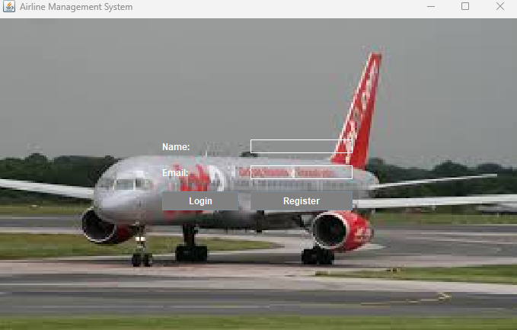
CODE OUTPUTS:
